# C1 Diagram:

This is the outline of the basic structure of the code. Where a user will enteract with the front end which will lead to the back end.

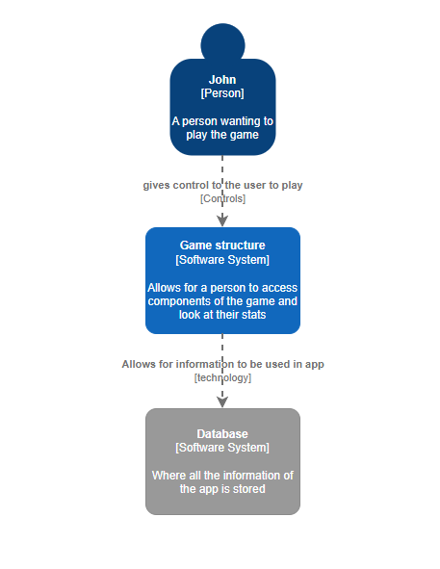

# C2 Diagram:

The consumer interacts with the website which will call upon the web application for information. The Web Pages will use JavaScript and React to allow for easy interactions with the code and being taught in it. Web Application will use Java which I am being taught in and it is a wildly used language.

C3 Diagram

The consumer will access the front page of the website which will allow for the user to retrieve or receive information from the Api.

